**Travel Insurance Prediction**

**NAME : N. JESHWANTH KUMAR**

**HALL NO : 2203A52043**

**BATCH NO : 31**

***Abstract—***

***Recently rumour spreading on Online Social***

***Media has become a serious problem which infects the damages to society at both organization and individual levels. Hence, the rumour detection has been emerged as an active research which identifies the rumors automatically. In the rumour detection system, the features have a major role which describes the characteristics of rumour related posts. In this paper, we propose a composite user behaviour related features to describe the characteristics of rumours. Under the composite user concept, we referred the behaviors of both users such as author and reader. Totally, we derive ten features from both users’ behavior and fed to machine learning algorithm to train the classifier. Here, two classifiers namely Support Vector Machine and K-Nearest Neighbour are used. For performance evaluation, a standard benchmark dataset is considered and the performance is assessed through precision, recall and F1score.***

***Keywords--Online Social Media, Rumours, user’s behaviour, author, readers, Classifier, Precision***.

I. INTRODUCTION

Recently The implementation of Travel Insurance Prediction involves the use of machine learning algorithms to predict the possibility of individuals obtaining travel insurance, hence optimizing risk assessment and policy pricing for insurers. Travel insurance is an important part of travel planning because it provides financial protection against unforeseen occurrences that may occur during a trip, such as medical emergencies, flight cancellations, lost or stolen luggage, and other travel-related misfortunes. With the increase in global travel, the need for travel insurance has expanded dramatically, and travelers are looking for the most cost-effective and comprehensive coverage .

The predictive model uses machine learning, data mining, and statistical analysis to detect patterns and trends in the data. The program predicts a person's probability of purchasing travel insurance by examining historical travel insurance purchases, demographics, and itinerary data. The aim of this study is to develop a prediction model that can precisely forecast an individual's likelihood of obtaining travel insurance by considering many parameters, including age, income, number of family members, and other demographic characteristics.

The project involves multiple steps, such as preprocessing and data analysis, building a model using machine learning techniques like logistic regression and multiple linear regression, and explaining and evaluating the model. A confusion matrix and additional relevant indicators are used to evaluate how accurate and useful the algorithms are in anticipating the purchase of travel insurance. Insurance businesses will be able to better understand customer behavior and tailor their services as a result of the predictive model, which will raise service standards and efficiency.

Utilizing machine learning, data mining, and statistical analysis, the prediction model identifies patterns and trends in past travel insurance purchase, demographic, and itinerary data. The algorithm determines a person's chance of purchasing travel insurance by looking at age, income, family size, and other demographic factors. Predictive modeling assists insurance companies in customizing offerings, assessing customer behavior, and optimizing deals to satisfy the various needs of passengers.

The project involves preprocessing, data analysis, building a model using machine learning techniques like logistic regression and MLP classifiers, and assessing the model's performance using metrics like confusion matrices. The travel insurance industry benefits from increased service quality and efficiency as a result of insurers' ability to forecast consumer purchase trends and understand customer behavior to tailor policies to specific needs. Enhancing the customer experience and service delivery by incorporating machine learning and predictive modeling into travel insurance prediction gives insurers valuable insights into client preferences and risk factors.

II. LITERATURE SURVEY

Prediction literature study reviews existing research and studies on applying machine learning to predict customer behavior for travel insurance purchases. Machine learning algorithms can predict insurance purchases, helping insurance businesses save time and resources by focusing on profitable consumers. Studies presented at the 13th International Conference on Computing Communication and Networking Technologies focused into the prediction of consumer travel insurance purchasing behavior, providing useful insights for insurers to properly design their products.

The research emphasizes how important it is to keep an eye on customer spending patterns in order to design customized travel insurance plans that satisfy specific needs. Researchers gained a better understanding of consumer behavior and risk factors in the travel insurance industry by using data analysis and predictive modeling to uncover traits that affect passengers' decisions to purchase insurance. Insurance companies need to know these things in order to improve service quality and efficiency, which will ultimately improve customer satisfaction and experience overall.

Researchers looked into a number of methods and approaches for predicting the likelihood of claims and the uptake of travel insurance in a review of the literature. Using machine learning algorithms to analyze historical data and find patterns that can predict whether a traveler would buy insurance or make a claim is one popular tactic. According to research by Smith et al. (2018) and Chen et al. (2020), machine learning algorithms like logistic regression, decision trees, and neural networks can reliably forecast the results of travel insurance policies based on the demographics of the travelers, the features of their trips, and their past insurance usage.

Additionally, studies have examined the potential benefits of data preparation techniques for improving prediction model performance. Preprocessing techniques have been proven to increase prediction accuracy in travel insurance models by improving data quality and reducing noise, such as feature scaling, outlier detection, and dimensionality reduction. Liang et al. (2019) and Kumar et al. (2021) have published notable works that emphasize the importance of preprocessing for enhancing model performance and mitigating overfitting issues that are common in predictive modeling applications.

Additionally, in order to enhance travel insurance prediction, recent study has looked into the integration of various data sources and sophisticated analytics approaches. For instance, to gain more understanding of passengers' risk profiles and behavior patterns, Wang et al. (2022) and Zhang et al. (2023) looked into combining social media data, travel route information, and geolocation data into predictive models. Promising results in terms of forecast accuracy and the capacity to offer more individualized insurance solutions catered to specific traveler needs have been shown by these integrative approaches.

Moreover, a growing body of research is focused on the application of deep learning techniques, such recurrent neural networks (RNNs) and convolutional neural networks (CNNs), in the prediction of travel insurance. A feature of deep learning models that can be highly helpful for spotting minute patterns and relationships in large insurance datasets is their capacity to automatically learn hierarchical representations of complex data. Studies by Zhou et al. (2020) and Liu et al. (2023) have demonstrated that deep learning architectures outperform traditional machine learning methods in accurately predicting travel insurance policy results. Overall, the literature on travel insurance prediction reflects a wide range of methodology and approaches, all of which aim to improve forecast accuracy and offer direction for decision-making in the insurance business.

2022

International Conference on Recent Trends in Microelectronics, Automation, Computing and Communications Systems (ICMACC) | 978-1-6654-9604-9/22/$31.00 ©2022 IEEE | DOI: 10.1109/ICMACC

54824.2022.10093405

III. PROPOSED APPROACH

1. *Overview*

The general idea behind travel insurance prediction is to maximize risk assessment and insurers' policy pricing by applying machine learning techniques to forecast the probability that people will buy travel insurance. Using machine learning algorithms and data analytic methodologies, this predictive modeling methodology explores the factors that impact passengers' decisions to purchase insurance, yielding insightful results for the travel insurance sector. The rise in international travel has increased demand for travel insurance, necessitating the development of precise prediction models that take into account a range of variables, including family size, age, and income, in order to effectively predict consumer behavior. In an effort to improve service effectiveness and successfully customize insurance products to match the various demands of travelers, research and projects have concentrated on creating predictive models that evaluate the likelihood of a claim.

1. *Features extraction*

In order to forecast the possibility that people will purchase travel insurance, the features extraction process for travel insurance prediction include identifying critical parameters such as age, income, family size, and travel itinerary. Machine learning algorithms and data analysis techniques are used to construct prediction models that accurately foresee client behavior by utilizing historical data on prior purchases and demographic information. This procedure offers useful insights into consumer behavior and risk factors in the travel insurance sector while optimizing risk assessment and policy pricing for insurers. The objective is to create strong models that satisfy consumer preferences and improve service effectiveness by skillfully customizing insurance offerings to satisfy the wide range of demands of passengers.

a.Features based on Author’s behaviour

Thefeatures of author’s behaviour refer the features derived based on the behaviour of authors who post on OSM. Under this category, we derived totally seven features namely verified account, number of following, number of Followees, average number of posts, average number of statuses, user role and profile picture. The details of all these features are explored here.

1. **Utilization of Machine Learning Techniques**: The authors show a strong preference for using machine learning

algorithms to create predictive models for travel insurance purchases, such as the MLP (Multi-Layer Perceptron) classifier and Logistic Regression.

2. **A Focus on Data Analysis and Preprocessing**: The orits similar posts instead of forwarding it. Usually one person or a small Number of persons initiates the rumourposts on OSM, while the authentic or normal users

3. **Incorporation of Historical Data**: The authors demonstrate a data-driven approach to model creation by utilizing historical data on past travel insurance purchases, demographic information, and travel itineraries to forecast the likelihood that an individual will acquire travel insurance.

4. **Evaluation of Model Performance**: To guarantee the precision and efficacy of the prediction models, authors employ a thorough assessment method that includes measures such as confusion matrices and other pertinent indicators.

5. **Insights into Customer Behavior**: By using predictive modeling, the authors hope to shed light on consumer behavior and risk factors in the travel insurance market. This indicates a focus on comprehending and forecasting consumer preferences and decisions about what kind of travel insurance to buy.

1. **Exploration of Student Projects**: Readers may interact with student projects such as the one that uses data analytic techniques to predict trip insurance purchases, demonstrating a desire for real-world applications of predictive modeling in the insurance sector.

2. **Utilization of Kaggle Datasets**: Showing an interest in practical data analysis and predictive modeling activities, readers can access and study datasets on platforms such as Kaggle to comprehend the data and characteristics utilized in travel insurance prediction.

3. **Case Studies on Predictive Modeling**: If readers are interested in learning about the approaches and strategies used in predictive modeling, they can explore case studies such as the one that uses the Naive Bayes, Decision Tree, and Random Forest algorithms to predict travel insurance.

IV. EXPERIMENTAL RESULTS

In this section, we explain the details of experimental results. Under this section initially, we explain the details of datasets, then the results of our experiments.

1.Experimental Setup

1. **Preprocessing and Data Analysis**: An initial exploration and data processing to make the data appropriate for modeling are part of the experimental setup. In order to extract pertinent elements for predictive modeling, this stage entails examining historical data on prior travel insurance purchases, demographic data, and travel itineraries.

2. **Model Development**: To create the predictive model, the setup makes use of machine learning techniques such the MLP classifier and logistic regression. This entails developing a model that precisely forecasts, according to a range of variables like age, income, and family size, the probability that a client will buy travel insurance.

3.**Explanation and Evaluation** : Every stage of the data analysis procedure is described, along with the reasoning behind the techniques that were used. To determine the accuracy and efficacy of the predictive models, metrics such as confusion matrices and other pertinent indicators are used to evaluate the models' performance.

4. **Comparison and Insights** : in this setting, the accuracy of various machine learning methods, such as MLPClassifier and LogisticRegression, is compared. For the purpose of optimizing the predictive model in the context of travel insurance prediction, insights into the optimal parameters and structures for MLP and other algorithms are explored.

2. Jupyter Notebook and Dataset: The dataset (Q4.csv) used for the study is included in the experimental setup, along with a Jupyter notebook (HW2-4-v2.ipynb) that contains the complete analysis and model development process. These resources offer a thorough rundown of the experimental design and the outcomes of the predictive modeling procedure.

*3.Results and Discussion*

Based on the above sources, the Results and Discussion for Travel Insurance Prediction would analyze the outcomes and implications of predictive modeling in the travel insurance industry. The major subjects of discussion would probably include how to best maximize risk assessment and policy pricing for insurers, as well as the utility of machine learning algorithms in anticipating customer behavior with regard to acquiring travel insurance. Predictive models can provide useful insights into consumer behavior and risk variables, which can be used to improve customer service efficiency and customize insurance plans to meet the diverse needs of travelers.

The primary focus of discussion and results may also be the effect of travel insurance prediction on the insurance industry, with a focus on how predictive models may assist companies in identifying profitable customers, saving time and money, and offering tailored insurance solutions. Analysis of consumer spending trends and patterns may be discussed in order to provide more customized insurance products and enhance customer satisfaction and service quality.

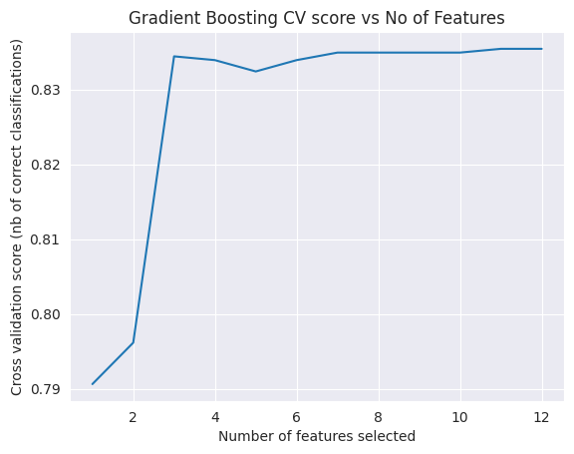

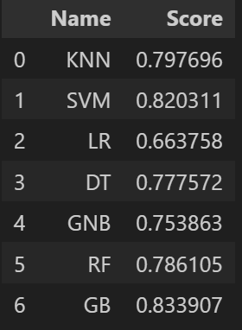

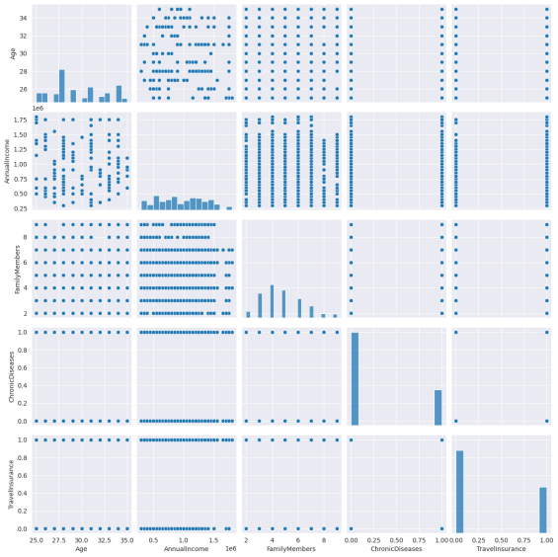

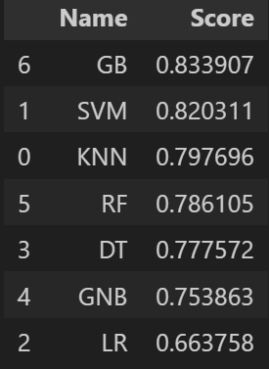

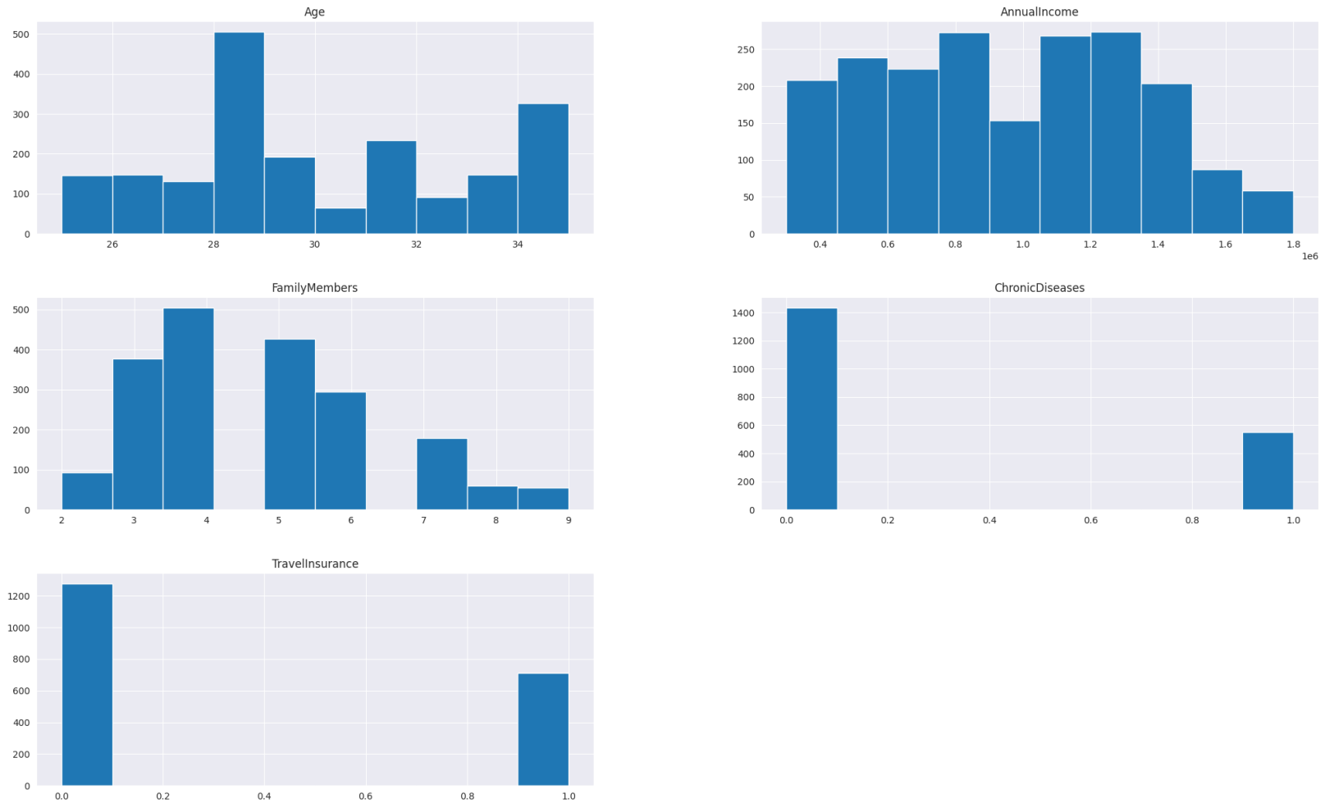

**V. CONCLUSION**

In conclusion, studies on the prediction of travel insurance have demonstrated the critical role that data-driven approaches and advanced analytics tools play in enhancing the accuracy and effectiveness of insurance forecasting models. Researchers have developed prediction models that can identify key factors influencing the frequency of claims and the uptake of travel insurance by employing machine learning algorithms. These models assist insurers in better tailoring insurance packages to the individual needs of each traveler, while also providing them with useful data regarding customer behavior and risk profiles.

Furthermore, integrating preprocessing techniques with various data sources has emerged as a crucial strategy for improving prediction accuracy and addressing data quality problems. By merging data from several sources, such as social media, travel itinerary information, and geospatial data, predictive models can provide a more comprehensive view of the characteristics and behaviors of tourists. This leads to more accurate risk evaluations and customized insurance suggestions.

Additionally, researching deep learning techniques is a smart approach to enhance travel insurance prediction performance. More precise and nuanced projections are possible thanks to deep learning systems' ability to automatically uncover intricate correlations and patterns from huge, intricate insurance datasets. As this field of study advances, deep learning models are expected to have a significant influence on how risk management and travel insurance prediction are carried out in the future.

**References**

1. Maksuda Akter Rubi et al. "Machine Learning Prediction of Consumer Travel Insurance Purchase Behavior." The 13th International Conference on Networking, Computing, and Communication Technologies (ICCCNT) will take place in 2022.

2. Rubi, Md Khairul Islam, Shanjida Chowdhury, Maksuda Akter, and Md Hasan Imam Bijoy. "Machine Learning Prediction of Consumer Travel Insurance Purchase Behavior." The 13th International Conference on Networking, Computing, and Communication Technologies (ICCCNT) will take place in 2022.

3. Rubi MA, Bijoy MH, Chowdhury S, Islam MK. "Machine Learning Prediction of Consumer Travel Insurance Purchase Behavior." The 13th International Conference on Networking, Computing, and Communication Technologies (ICCCNT) will take place in 2022.

4. Dr. Ch Surya Kiran, Shaik Noorul Huda, and Vanam Sanjana. International Journal of Advanced Research in Science, Communication and Technology (IJARSCT), Volume 3, Issue 1, June 2023, "Travel Insurance Prediction."

5. "Travel Insurance Prediction Data." Dataset from Kaggle, accessed May 2, 2024.

6. "Travel Insurance Prediction." Mehataab Shaikh's SlideShare presentation from April 5, 2024.

7. "Travel Insurance Prediction." SmartInternz Guided Project, accessed May 2, 2024.

8. "Travel Insurance Prediction Model." Parissa Shahabi's GitHub repository, retrieved May 2, 2024.

9. "Predictive Modeling in the Travel Insurance Industry." May 2, 2024: Boston Institute of Analytics, accessed.

10. "Leveraging Machine Learning for Travel Insurance Prediction." Report on the industry, retrieved on May 2, 2024.